Subquery Part 02

**Exercise 01:-**

STEP 1. what is the department id for the IT department

SQL Code:

SELECT

department_id

FROM

departments

WHERE

department_name = 'IT';

**Output:**

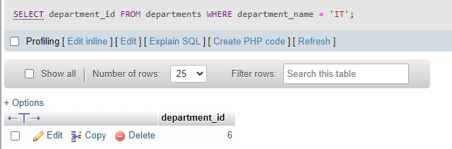

STEP 2. work out the average salary from the department, corresponding to the IT department.

5760 – FROM simply from a postage stamp calculation

SQL Code:

SELECT

AVG(salary)

FROM employees

WHERE

department_id = 6;

**Output Answer:**

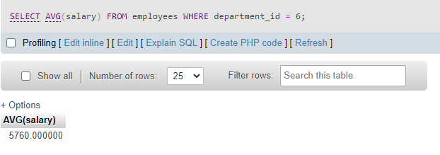

STEP 3. Write the main query - and use the average salary amount to get a view of the output (THE ANSWER)

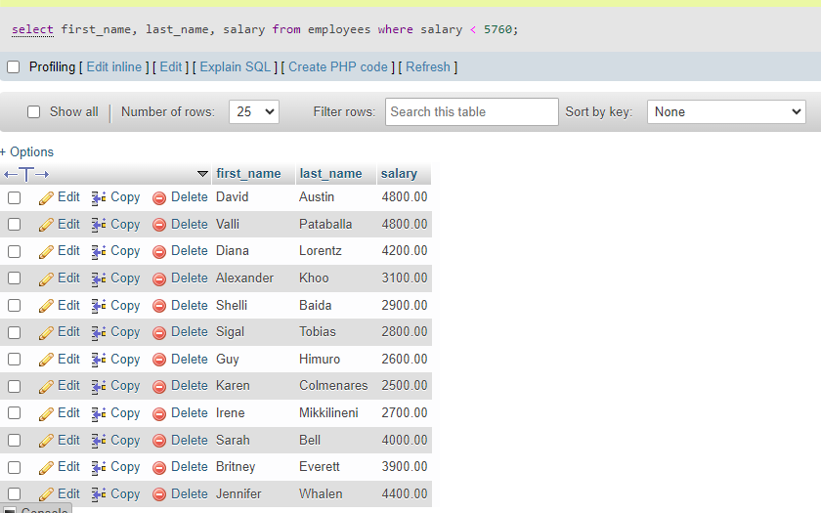

STEP 4: Rewrite the query this time with the main + subquery - to generate same answer as STEP 3

SELECT

first_name,

last_name,

salary

FROM

employees

WHERE

salary < ALL

(SELECT

AVG(salary)

FROM

employees

WHERE

department_id = 6)

ORDER BY

salary;

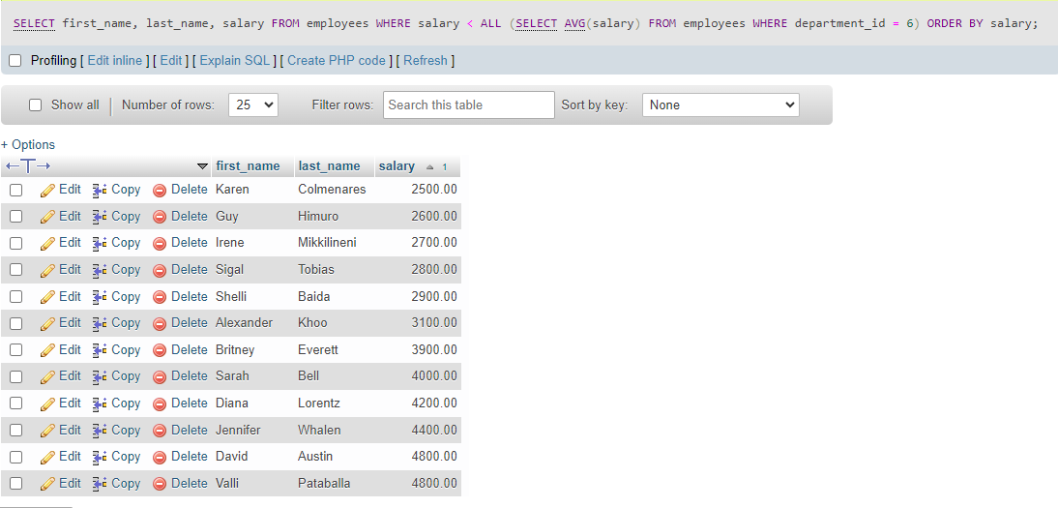

Exercise 02:  Determine all of the employees earning more than the minimum salary earnt in the sales department

STEP 1. What is the department id for the sales department

SQL Coding:

SELECT

department_id

FROM

departments

WHERE

department_name = 'Sales';

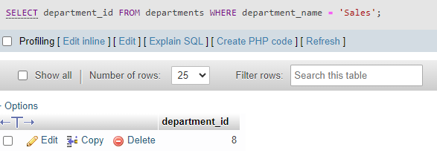

STEP 2. work out the minimum salary from the department, corresponding to the sales department.

SQL Code:

SELECT

MIN(salary)

FROM

employees

WHERE

department_id = 8;

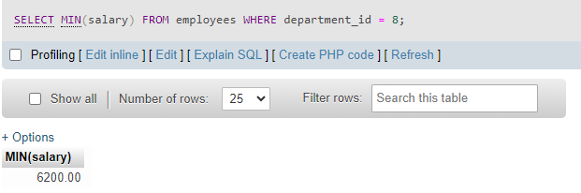

STEP 3. Write the main query - and use the min salary from sales department amount to get a view of the output (THE ANSWER)

select min(salary)

from employees

where department_id = 8;

STEP 4: Rewrite the query this time with the main + subquery - to generate same answer as STEP 3

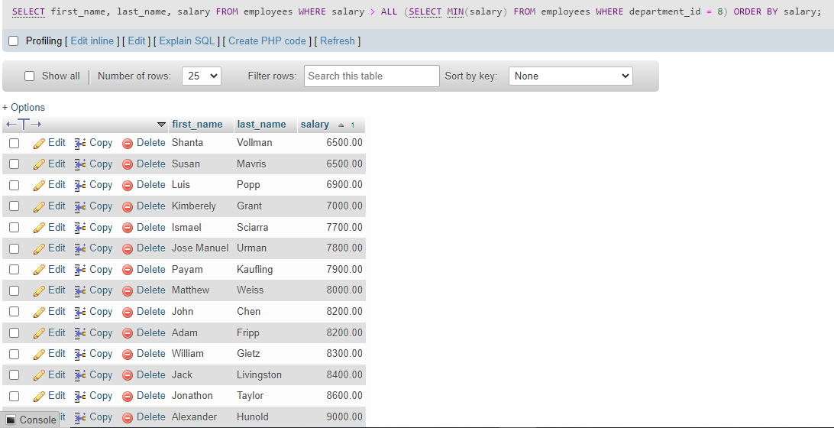

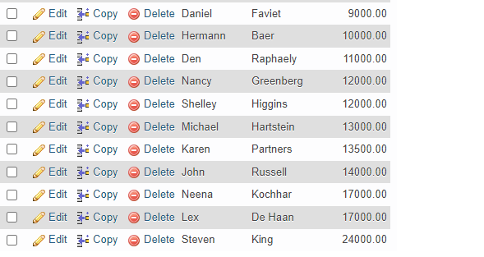

Construct an sql that will find <> which means no matches

SELECT

    first_name, last_name, salary, department_id

FROM

    employees

WHERE

    salary <> ALL (SELECT

            AVG(salary)

        FROM

            employees

        GROUP BY department_id)

ORDER BY salary DESC;

No where statement here – so what is it comparing?

Not returning a single value – its return a series of values that correspond to the Averages from each of the departments.